Input:
using System;

namespace Computer_Programming_Lab_08
{
class Program
{
static void Main(string[] args)
{
int m = 5; //Rows
int n = 4; //Col
string[,] profile = new string[m, n];
//titles
profile[0, 0] = "Name";
profile[0, 1] = "Phone No";
profile[0, 2] = "Designation";
profile[0, 3] = "Department";
//row 1
profile[1, 0] = "Abdullah";
profile[1, 1] = "000000000";
profile[1, 2] = "Jr.Dev";
profile[1, 3] = "BSE";
//row 2
profile[2, 0] = "Shahzaib";
profile[2, 1] = "000000000";
profile[2, 2] = "Sr.Dev";
profile[2, 3] = "BSCS";
// Printing of 2D Array
for (int i =0; i<m; i++)
{
for (int j = 0; j < n; j++)
{
Console.Write("{0}\t\t",profile[i,j]);
}
Console.WriteLine();
}
}
}
}
Output:
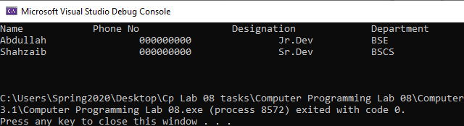

Input:
using System;

namespace Computer_Programming_Lab_08
{
class Program
{
static void Main(string[] args)
{
int m = 5; //Rows
int n = 4; //Col
string[,] profile = new string[m, n];
//titles
profile[0, 0] = "Name";
profile[0, 1] = "Phone No";
profile[0, 2] = "Designation";
profile[0, 3] = "Department";

for (int i =1; i<m; i++)
{
for (int j = 0; j < n; j++)
{
if (j == 0)
{
Console.WriteLine("Enter name");
profile[i, j] = Console.ReadLine();
}
else if (j == 1)
{
Console.WriteLine("Enter phone Number");
profile[i, j] = Console.ReadLine();
}
else if (j == 2)
{
Console.WriteLine("Enter Designation");
profile[i, j] = Console.ReadLine();
}
else
{
Console.WriteLine("Enter Department");
profile[i, j] = Console.ReadLine();
}
}
Console.WriteLine("Enter Profile {0}", i+2);
}
Console.WriteLine("/n++++++++++Profile Summry++++++++++");
for (int i = 1; i < m; i++)
{
for (int j = 0; j < n; j++)
{
Console.WriteLine("{0}", profile[i,j]);
}
}
}
}
}

